**CSS Cascade**

Cascading means is my the CSS applied to one element overchanges the the another element.

For example:-

There are four categories on which level of importance of CSS has rules :-

1:-Position

2:- Specificity

3:-type

4:- importance

Imp :- In internal and external css the lower the css rules then more important it is .

For example:-

**Combining CSS selectors**

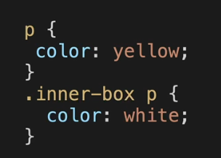As we create selectors for individual CSS we can also combines the selectors and use the CSS property in it.

There are rules for combining the CSS selectors:-

1:- **Group** :- In group selector we basically group the selectors by using , between them.

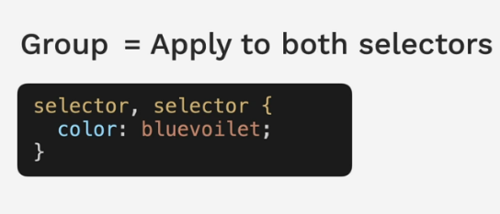For example:-

2:- **child** :- In child there is a parent and a child selector both are differentiated by ‘>’ sign and for this the child should be at one level only there should be no nested childs.

3:- **Descendant** :- This combination technique is very easy in this we can start by giving the ancestor and the descendant name , so It will apply CSS on descendant ,

For example if you two div elements nested and in that there is paragraph element then If you want to apply CSS on it then , we can use descendant technique like this

.class_name1 .class_name2 p{/* CSS in it*/

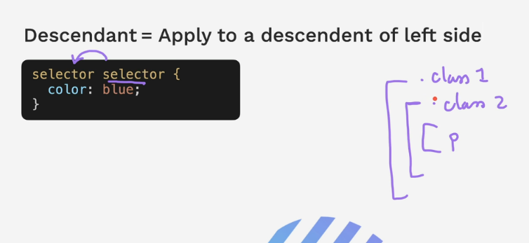}

4:- **chaining:-** in this selectors are selected without giving any space between them .

For example:-

5:- **combining combiners** :- As we have made the combinational selectors , so we will use this combinational selector with the ancestor tag so It will make more unique and can apply CSS more precisely.

For example:-

**CSS positioning**

In CSS the positioning is very important.

**There are four types of CSS positioning :-**

**1:- STATIC**

**2:- RELATIVE**

**3:-ABSOLUTE**

**4:- FIXED**

1:- **Static Positioning** :- Static Positioning is the default positioning in html page , whenever we give the positioning to static the default positions will be :-

2:- **Relative positioning** :- These positions the elements relative to default positions (static positions). Its means that it will take the static positions and relative to that we can give our position of us elements.

This is the design for understanding the

Relative positioning.

First element has been given the static

Positioning and the next element are been given the

Relative positioning form the static positions.

It is relative to supported location.

3:- **Absolute positioning**:-Absolute positioning is relative to nearest positions ancestor or top left corner of the webpage.

In this also if the ancestor has positioning relative

then It will have position relative to that ancestor.

But if it doesn’t have ancestor then it will take the

Top left corner of the webpage.

Another aspect of absolute positioning is the z – index

Z=0 it will come above the element

Z=-1 it will come below the element

4:- **Fixed Positioning:-** position relative to top left corner of the browser window.

It fixes at the window.